**LIBRARY DATABASE MANAGEMENT SYSTEM**

Sahana Jangali NUID:001491367

**Objective:**

Library is collection of all information and resources that is made accessible to university so that they can access or borrow them for their reference. This database system will keep track of the books, videos that are available in the library. It will also track customers who are borrowing books/online resources and their statuses. The database system will also track employees working at different location and branches.

**ER Diagram:**

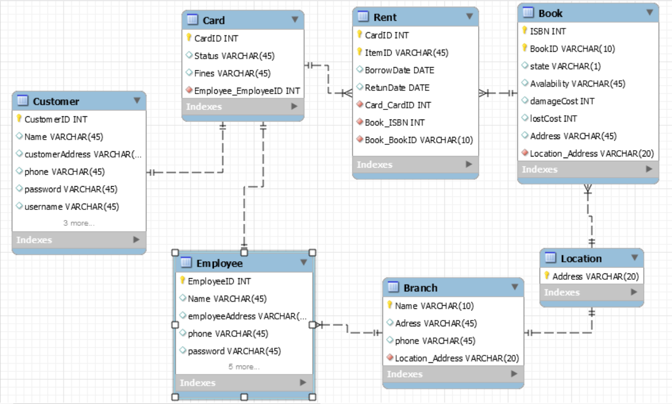

1. Logging into Oracle as sysdba; creation of CDB user;

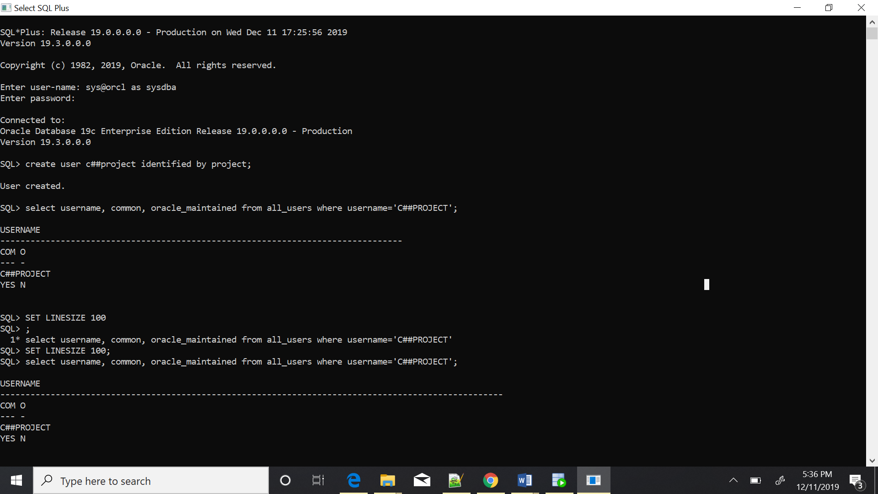

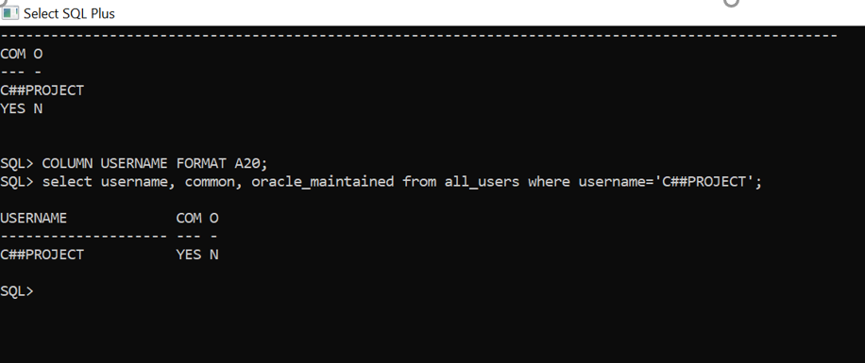

1. Creation of Pluggable database and PDB user:

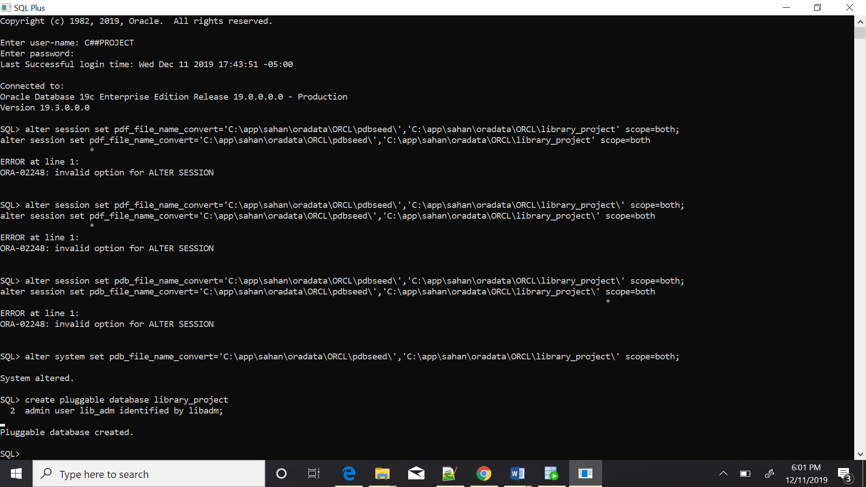

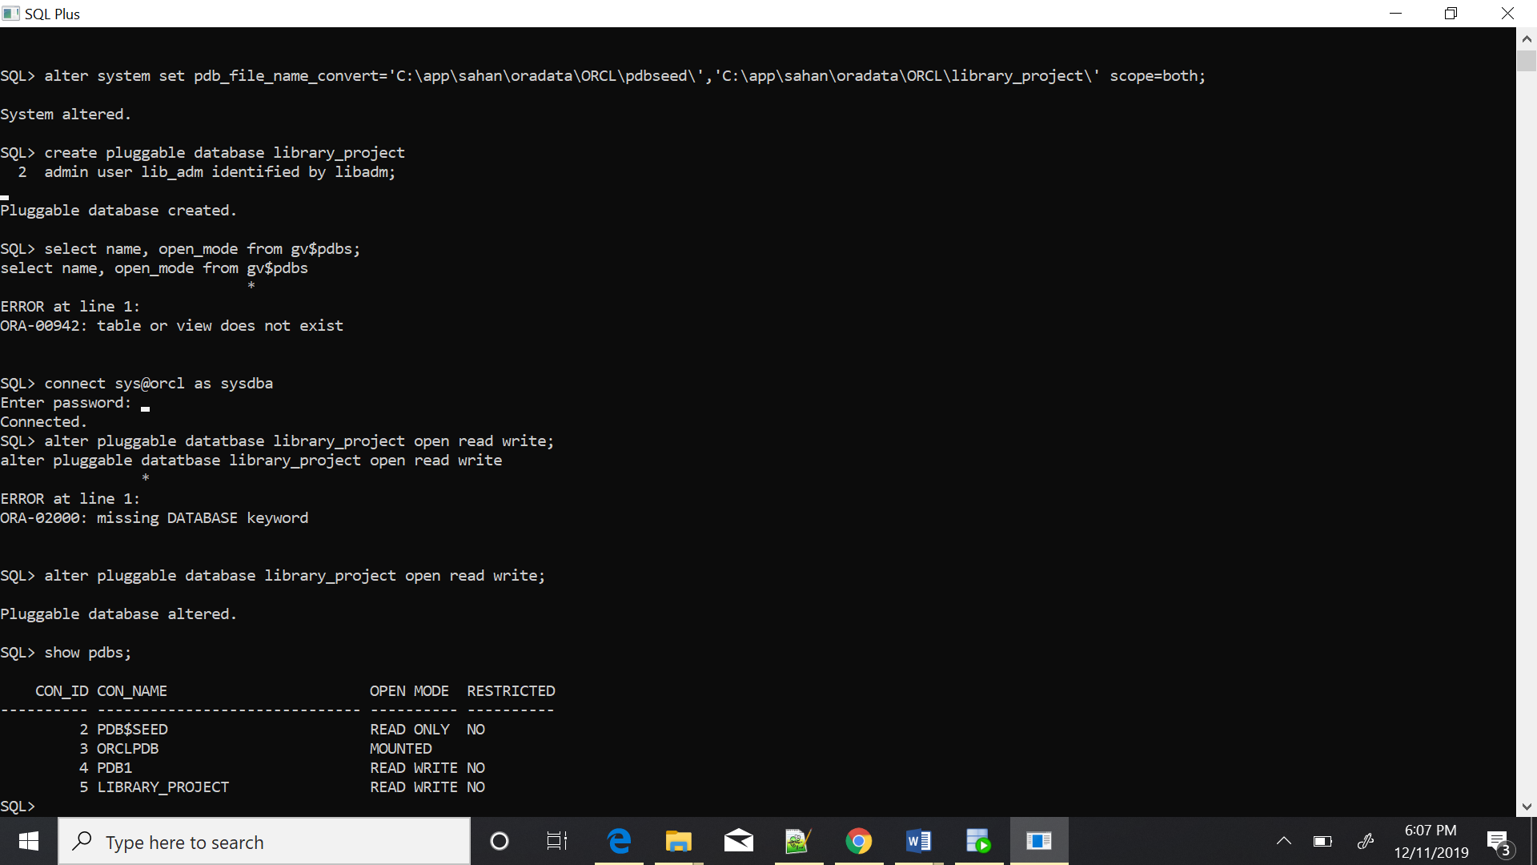

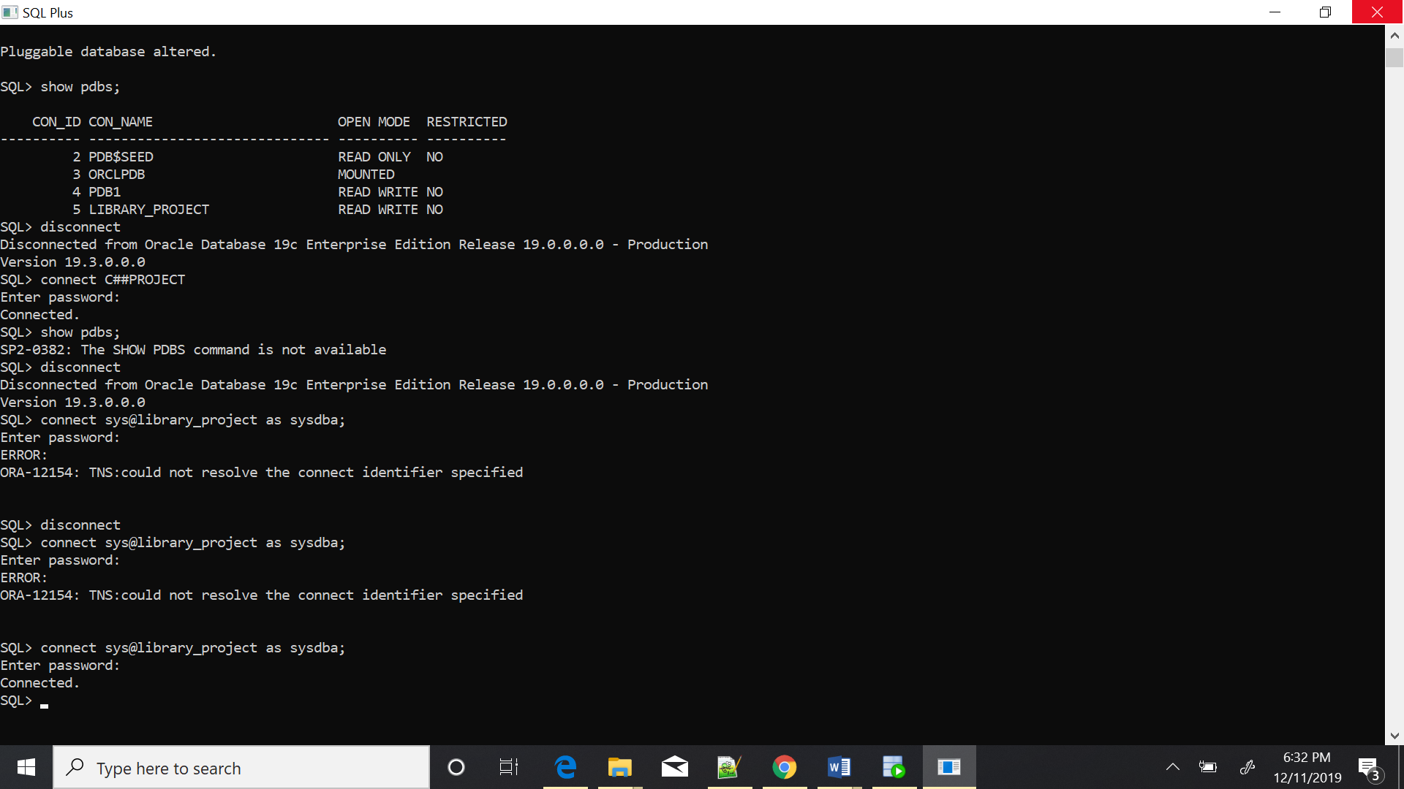

1. Creating tables:

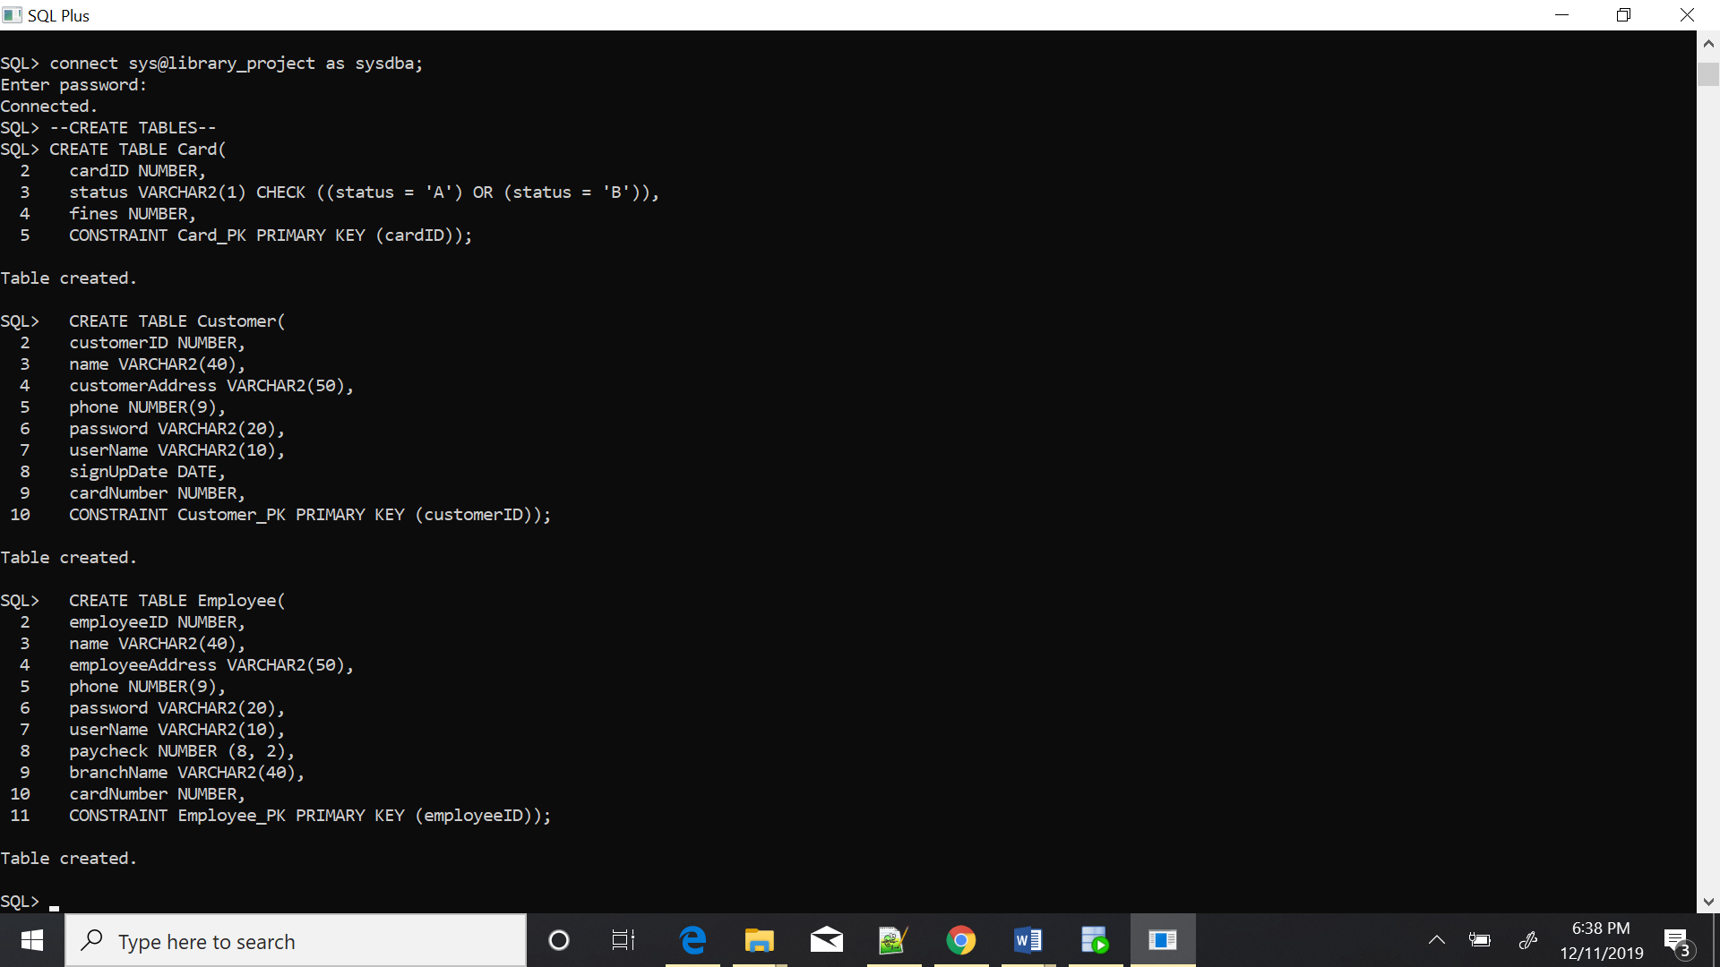

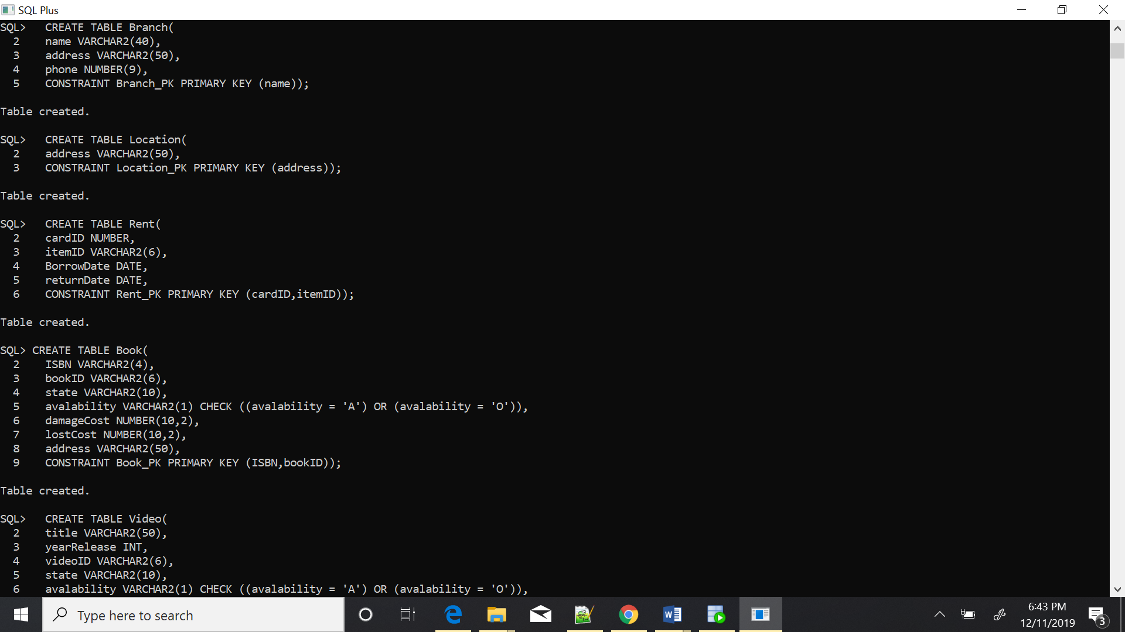

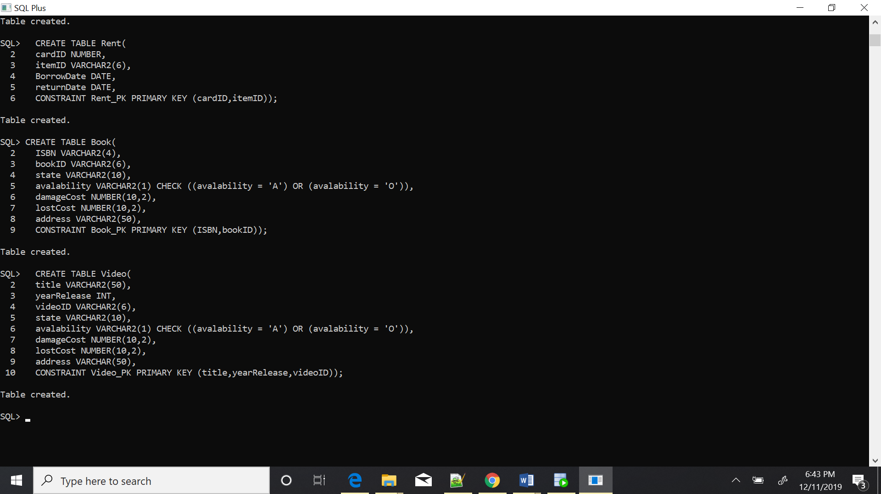

1. Adding foreign constraints to implement relationships between tables:

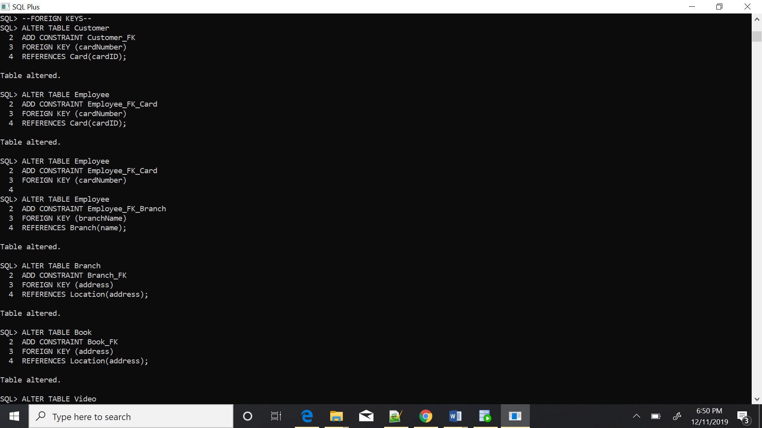

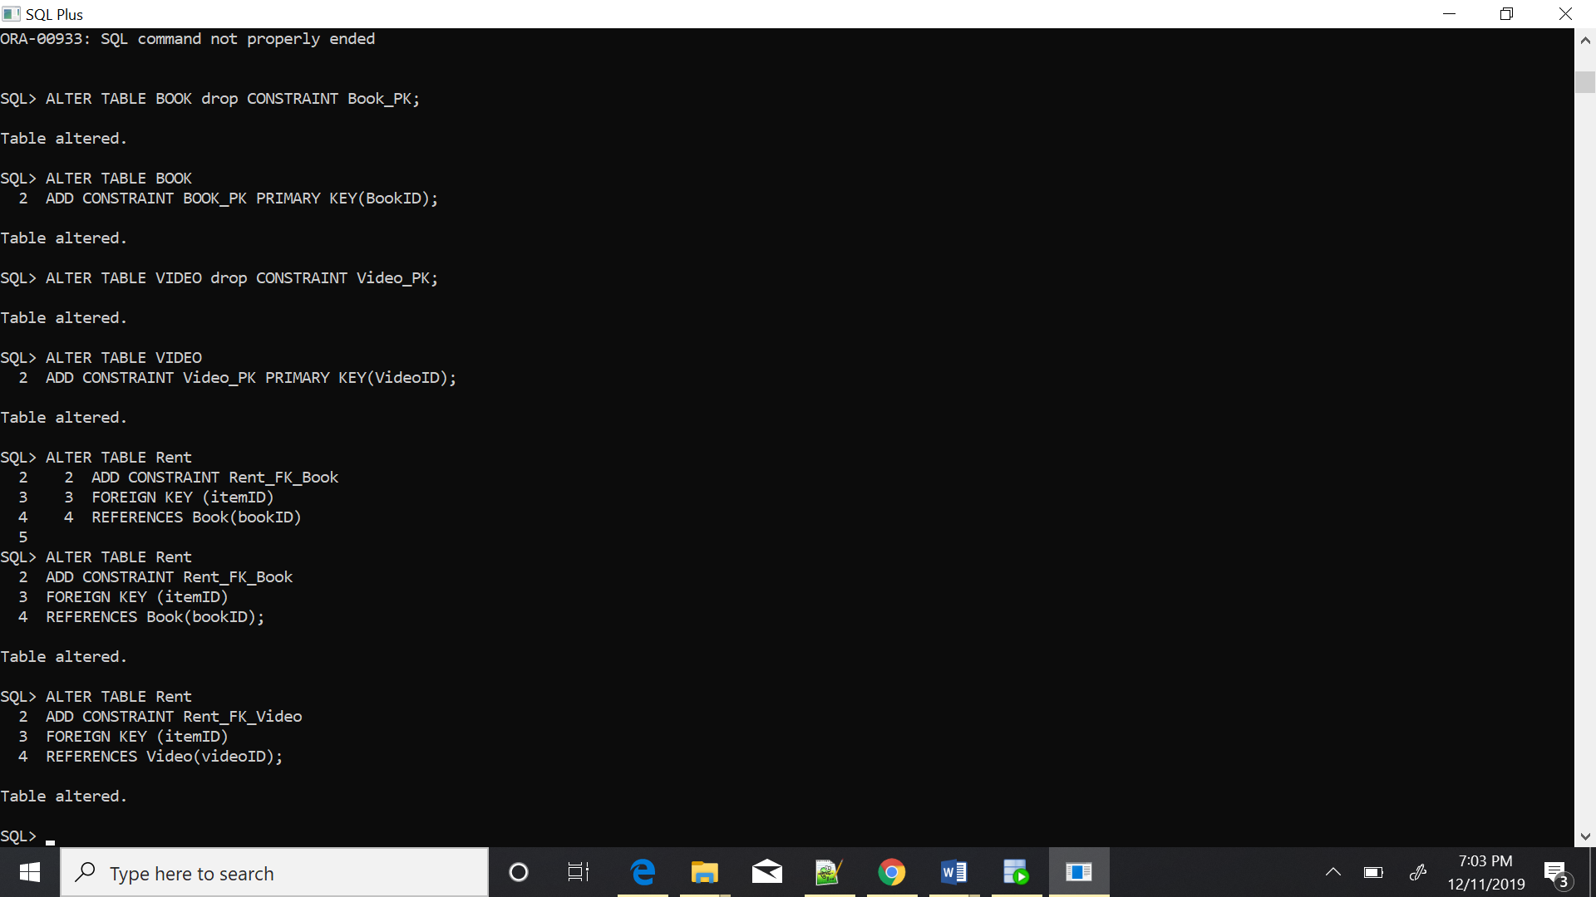

**Oracle Concepts**

1. External tables:

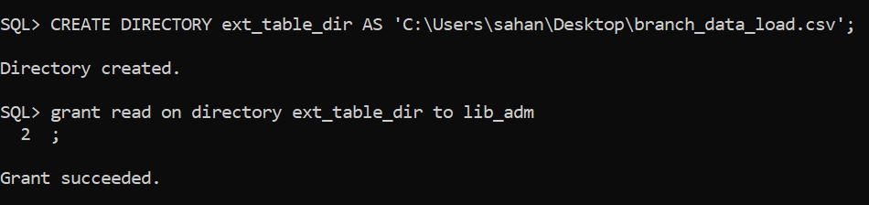

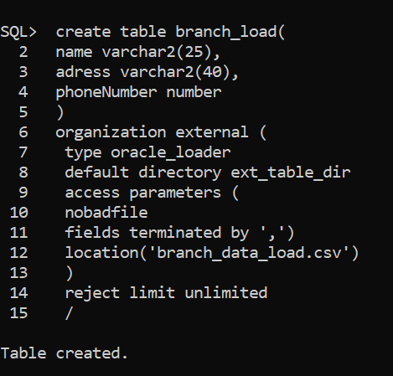

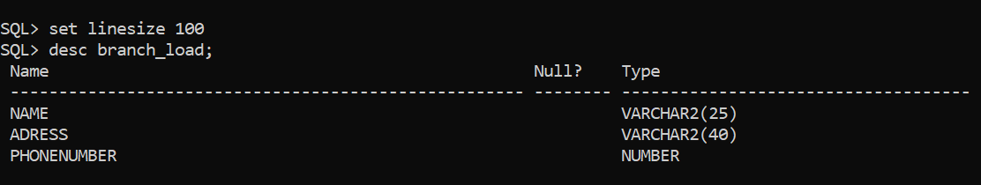

1. Relational view:

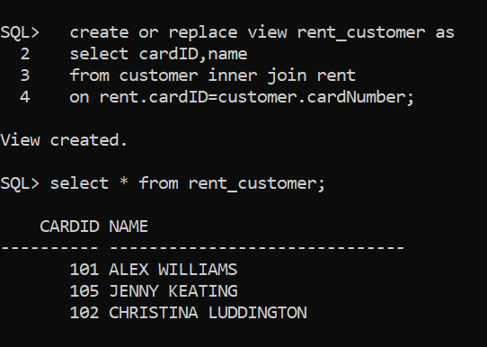

1. Inline views:

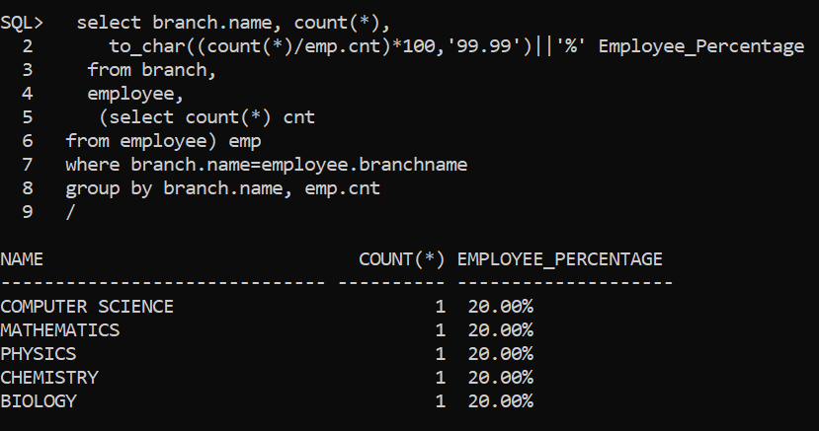

1. Materialized view:

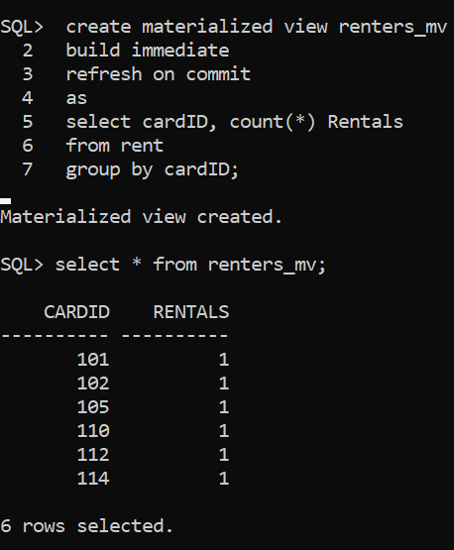

1. Procedure:

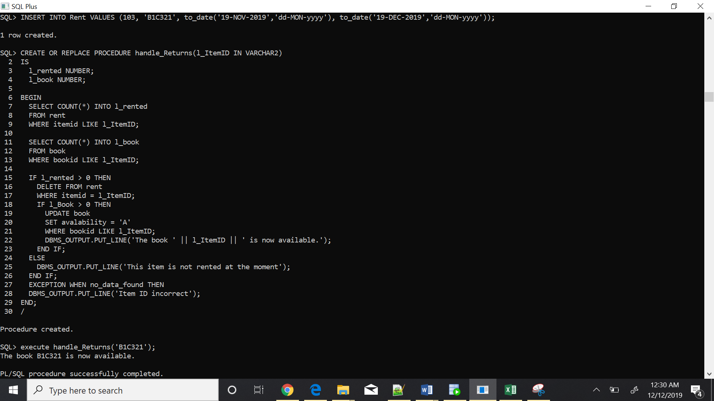

1. Trigger:

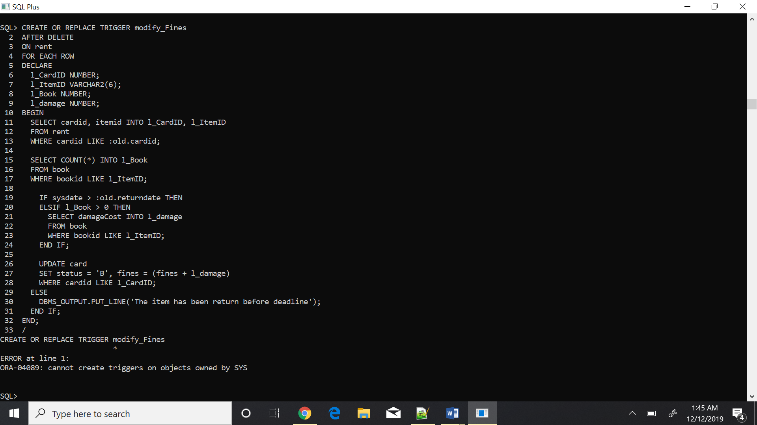

1. Index:

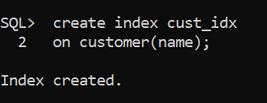

1. Explicit cursors:

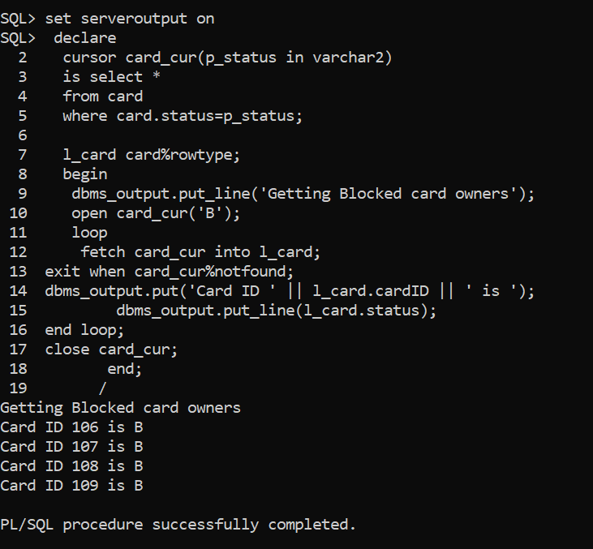

1. Transactions:

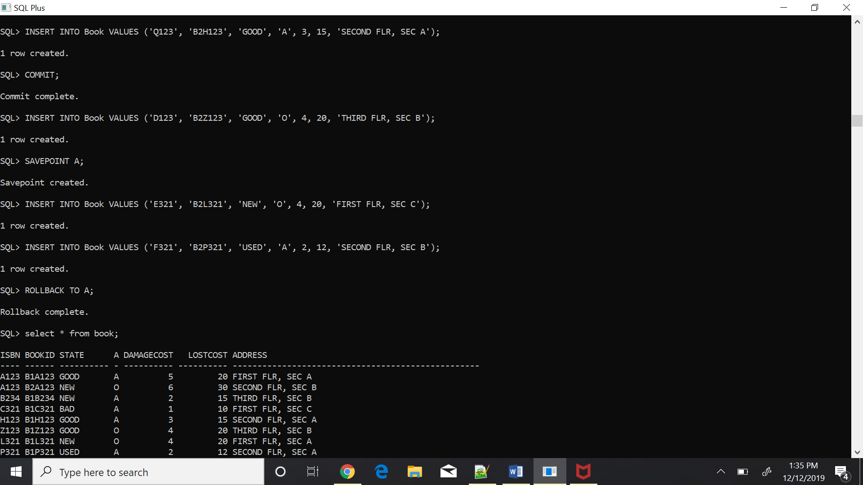

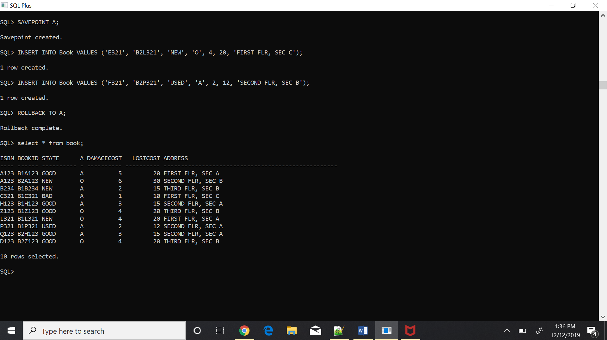

1. Functions:

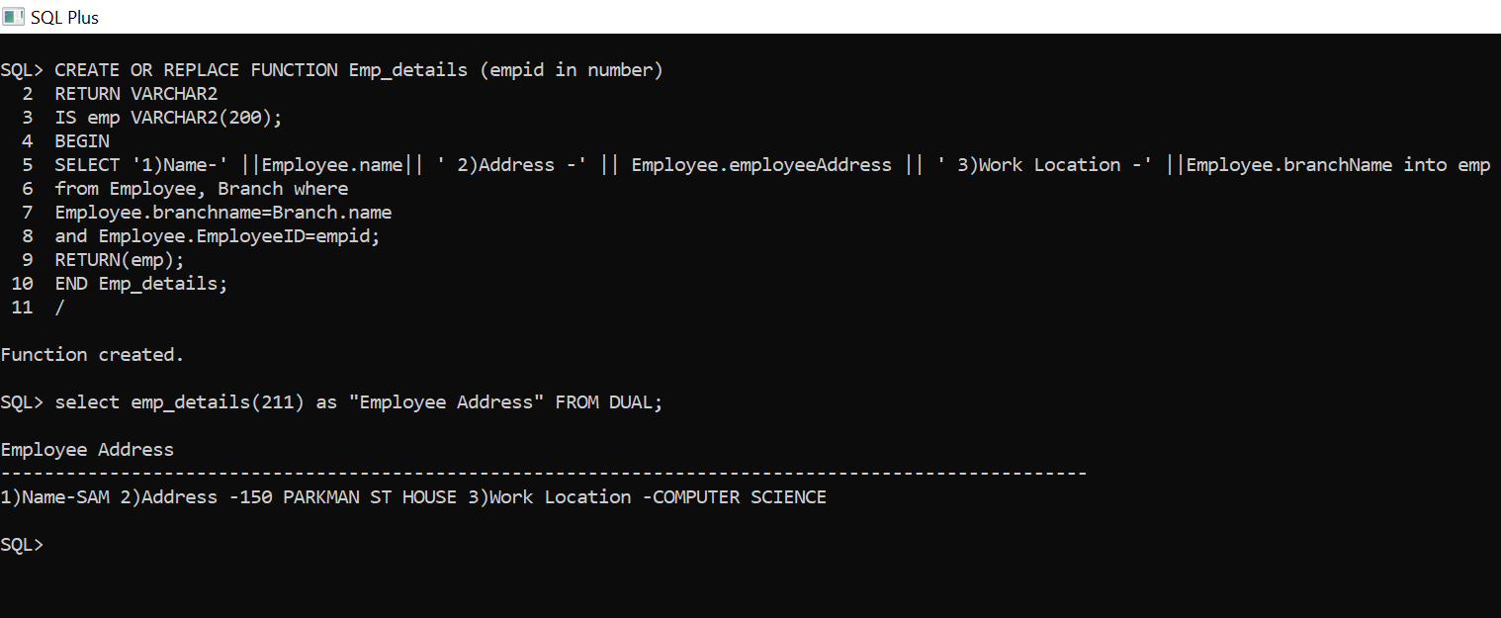

1. Ref cursors: Strongly typed

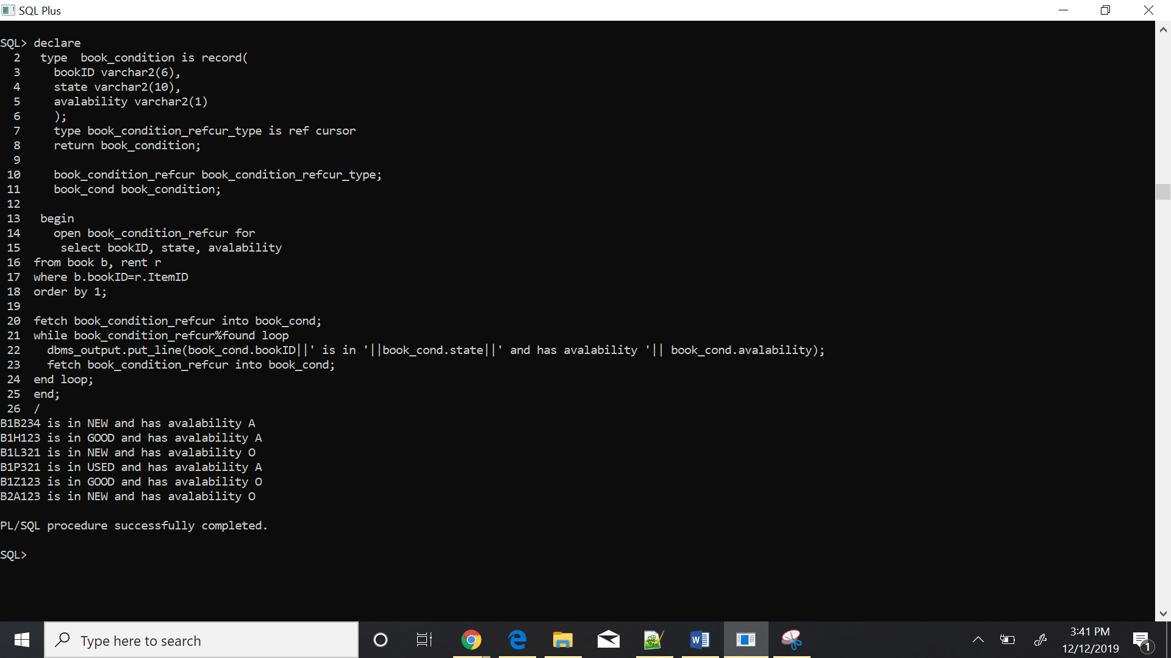

1. Pre defined exceptions

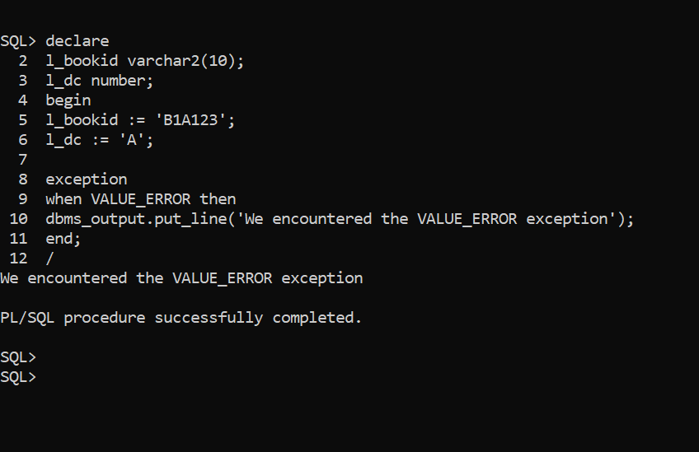

APPENDIX

SQL*Plus: Release 19.0.0.0.0 - Production on Wed Dec 11 17:58:07 2019

Version 19.3.0.0.0

Copyright (c) 1982, 2019, Oracle. All rights reserved.

Enter user-name: C##PROJECT

Enter password:

Last Successful login time: Wed Dec 11 2019 17:43:51 -05:00

Connected to:

Oracle Database 19c Enterprise Edition Release 19.0.0.0.0 - Production

Version 19.3.0.0.0

SQL> alter system set pdb_file_name_convert='C:\app\sahan\oradata\ORCL\pdbseed\','C:\app\sahan\oradata\ORCL\library_project\' scope=both;

System altered.

SQL> create pluggable database library_project

2 admin user lib_adm identified by libadm;

Pluggable database created.

SQL> connect sys@orcl as sysdba

Enter password:

Connected.

SQL> alter pluggable database library_project open read write;

Pluggable database altered.

SQL> show pdbs;

CON_ID CON_NAME OPEN MODE RESTRICTED

---------- ------------------------------ ---------- ----------

2 PDB$SEED READ ONLY NO

3 ORCLPDB MOUNTED

4 PDB1 READ WRITE NO

5 LIBRARY_PROJECT READ WRITE NO

SQL> disconnect

Disconnected from Oracle Database 19c Enterprise Edition Release 19.0.0.0.0 - Production

Version 19.3.0.0.0

SQL> connect C##PROJECT

Enter password:

Connected.

SQL> show pdbs;

SP2-0382: The SHOW PDBS command is not available

SQL> disconnect

Disconnected from Oracle Database 19c Enterprise Edition Release 19.0.0.0.0 - Production

Version 19.3.0.0.0

SQL> connect sys@library_project as sysdba;

Enter password:

Connected.

SQL> --CREATE TABLES--

SQL> CREATE TABLE Card(

2 cardID NUMBER,

3 status VARCHAR2(1) CHECK ((status = 'A') OR (status = 'B')),

4 fines NUMBER,

5 CONSTRAINT Card_PK PRIMARY KEY (cardID));

Table created.

SQL> CREATE TABLE Customer(

2 customerID NUMBER,

3 name VARCHAR2(40),

4 customerAddress VARCHAR2(50),

5 phone NUMBER(9),

6 password VARCHAR2(20),

7 userName VARCHAR2(10),

8 signUpDate DATE,

9 cardNumber NUMBER,

10 CONSTRAINT Customer_PK PRIMARY KEY (customerID));

Table created.

SQL> CREATE TABLE Employee(

2 employeeID NUMBER,

3 name VARCHAR2(40),

4 employeeAddress VARCHAR2(50),

5 phone NUMBER(9),

6 password VARCHAR2(20),

7 userName VARCHAR2(10),

8 paycheck NUMBER (8, 2),

9 branchName VARCHAR2(40),

10 cardNumber NUMBER,

11 CONSTRAINT Employee_PK PRIMARY KEY (employeeID));

Table created.

SQL> CREATE TABLE Branch(

2 name VARCHAR2(40),

3 address VARCHAR2(50),

4 phone NUMBER(9),

5 CONSTRAINT Branch_PK PRIMARY KEY (name));

Table created.

SQL> CREATE TABLE Location(

2 address VARCHAR2(50),

3 CONSTRAINT Location_PK PRIMARY KEY (address));

Table created.

SQL> CREATE TABLE Rent(

2 cardID NUMBER,

3 itemID VARCHAR2(6),

4 BorrowDate DATE,

5 returnDate DATE,

6 CONSTRAINT Rent_PK PRIMARY KEY (cardID,itemID));

Table created.

SQL> CREATE TABLE Book(

2 ISBN VARCHAR2(4),

3 bookID VARCHAR2(6),

4 state VARCHAR2(10),

5 avalability VARCHAR2(1) CHECK ((avalability = 'A') OR (avalability = 'O')),

6 damageCost NUMBER(10,2),

7 lostCost NUMBER(10,2),

8 address VARCHAR2(50),

9 CONSTRAINT Book_PK PRIMARY KEY (ISBN,bookID));

Table created.

SQL> --FOREIGN KEYS--

SQL> ALTER TABLE Customer

2 ADD CONSTRAINT Customer_FK

3 FOREIGN KEY (cardNumber)

4 REFERENCES Card(cardID);

Table altered.

SQL> ALTER TABLE Employee

2 ADD CONSTRAINT Employee_FK_Card

3 FOREIGN KEY (cardNumber)

4 REFERENCES Card(cardID);

Table altered.

SQL> ALTER TABLE Employee

2 ADD CONSTRAINT Employee_FK_Card

3 FOREIGN KEY (cardNumber)

4

SQL> ALTER TABLE Employee

2 ADD CONSTRAINT Employee_FK_Branch

3 FOREIGN KEY (branchName)

4 REFERENCES Branch(name);

Table altered.

SQL> ALTER TABLE Branch

2 ADD CONSTRAINT Branch_FK

3 FOREIGN KEY (address)

4 REFERENCES Location(address);

Table altered.

SQL> ALTER TABLE Book

2 ADD CONSTRAINT Book_FK

3 FOREIGN KEY (address)

4 REFERENCES Location(address);

Table altered.

SQL> ALTER TABLE Rent

2 ADD CONSTRAINT Rent_FK_Card

3 FOREIGN KEY (cardID)

4 REFERENCES Card(cardID);

Table altered.

SQL> ALTER TABLE Rent

2 ADD CONSTRAINT Rent_FK_Book

3 FOREIGN KEY (itemID)

4 REFERENCES Book(bookID);

REFERENCES Book(bookID)

*

ERROR at line 4:

ORA-02270: no matching unique or primary key for this column-list

SQL> ALTER TABLE BOOK MODIFY CONSTRAINT Book_PK PRIMARY KEY(BookID);

ALTER TABLE BOOK MODIFY CONSTRAINT Book_PK PRIMARY KEY(BookID)

*

ERROR at line 1:

ORA-00933: SQL command not properly ended

SQL> ALTER TABLE BOOK drop CONSTRAINT Book_PK;

Table altered.

SQL> ALTER TABLE BOOK

2 ADD CONSTRAINT BOOK_PK PRIMARY KEY(BookID);

Table altered.

SQL> ALTER TABLE VIDEO drop CONSTRAINT Video_PK;

Table altered.

SQL> ALTER TABLE VIDEO

2 ADD CONSTRAINT Video_PK PRIMARY KEY(VideoID);

Table altered.

SQL> ALTER TABLE Rent

2 2 ADD CONSTRAINT Rent_FK_Book

3 3 FOREIGN KEY (itemID)

4 4 REFERENCES Book(bookID)

5

SQL> ALTER TABLE Rent

2 ADD CONSTRAINT Rent_FK_Book

3 FOREIGN KEY (itemID)

4 REFERENCES Book(bookID);

Table altered.

SQL> INSERT INTO Card VALUES (100,'A',0);

1 row created.

SQL> INSERT INTO Card VALUES (101,'A',0);

1 row created.

SQL> INSERT INTO Card VALUES (102,'A',0);

1 row created.

SQL> INSERT INTO Card VALUES (103,'A',13);

1 row created.

SQL> INSERT INTO Card VALUES (104,'A',0);

1 row created.

SQL> INSERT INTO Card VALUES (105,'A',0);

1 row created.

SQL> INSERT INTO Card VALUES (106,'B',0);

1 row created.

SQL> INSERT INTO Card VALUES (107,'B',10);

1 row created.

SQL> INSERT INTO Card VALUES (108,'B',20);

1 row created.

SQL> INSERT INTO Card VALUES (109,'B',0);

1 row created.

SQL> INSERT INTO Card VALUES (110,'A',0);

1 row created.

SQL> INSERT INTO Card VALUES (111,'A',0);

1 row created.

SQL> INSERT INTO Card VALUES (112,'A',6);

1 row created.

SQL> INSERT INTO Card VALUES (113,'A',0);

1 row created.

SQL> INSERT INTO Card VALUES (114,'A',0);

1 row created.

SQL> INSERT INTO Location VALUES ('FIRST FLR, SEC A');

1 row created.

SQL> INSERT INTO Location VALUES ('SECOND FLR, SEC B');

1 row created.

SQL> INSERT INTO Location VALUES ('THIRD FLR, SEC B');

1 row created.

SQL> INSERT INTO Location VALUES ('FIRST FLR, SEC C');

1 row created.

SQL> INSERT INTO Location VALUES ('SECOND FLR, SEC A');

1 row created.

SQL> INSERT INTO Branch VALUES ('COMPUTER SCIENCE', 'FIRST FLR, SEC A', 857303838);

1 row created.

SQL> INSERT INTO Branch VALUES ('CHEMISTRY', 'SECOND FLR, SEC B', 622863281);

1 row created.

SQL> INSERT INTO Branch VALUES ('BIOLOGY', 'THIRD FLR, SEC B', 642908944);

1 row created.

SQL> INSERT INTO Branch VALUES ('PHYSICS', 'FIRST FLR, SEC C', 768903666);

1 row created.

SQL> INSERT INTO Branch VALUES ('MATHEMATICS', 'SECOND FLR, SEC A', 657890561);

1 row created.

SQL> INSERT INTO Book VALUES ('A123', 'B1A123', 'GOOD', 'A', 5, 20, 'FIRST FLR, SEC A');

1 row created.

SQL> INSERT INTO Book VALUES ('A123', 'B2A123', 'NEW', 'O', 6, 30, 'SECOND FLR, SEC B');

1 row created.

SQL> INSERT INTO Book VALUES ('B234', 'B1B234', 'NEW', 'A', 2, 15, 'THIRD FLR, SEC B');

1 row created.

SQL> INSERT INTO Book VALUES ('C321', 'B1C321', 'BAD', 'A', 1, 10, 'FIRST FLR, SEC C');

1 row created.

SQL> INSERT INTO Book VALUES ('H123', 'B1H123', 'GOOD', 'A', 3, 15, 'SECOND FLR, SEC A');

1 row created.

SQL> INSERT INTO Book VALUES ('Z123', 'B1Z123', 'GOOD', 'O', 4, 20, 'THIRD FLR, SEC B');

1 row created.

SQL> INSERT INTO Book VALUES ('L321', 'B1L321', 'NEW', 'O', 4, 20, 'FIRST FLR, SEC A');

1 row created.

SQL> INSERT INTO Book VALUES ('P321', 'B1P321', 'USED', 'A', 2, 12, 'SECOND FLR, SEC A');

1 row created.

SQL> INSERT INTO Employee VALUES (211, 'SAM', '150 PARKMAN ST HOUSE', 671671671, 'SAM123', 'SAM1', 5000, 'COMPUTER SCIENCE', 110);

1 row created.

SQL> INSERT INTO Employee VALUES (212, 'WES', '13 HEARTH ST', 688688688, 'WES123', 'WES12', 3500.50, 'CHEMISTRY', 111);

1 row created.

SQL> INSERT INTO Employee VALUES (213, 'ASHER', '76 PERTH AVE', 628628628, 'ASHER123', 'ASHER13', 4570.75, 'BIOLOGY', 112);

1 row created.

SQL> INSERT INTO Employee VALUES (214, 'VICTOR', '89 INDIA ST', 654321987, 'VICTOR123', 'VICTOR14', 5575, 'PHYSICS', 113);

1 row created.

SQL> INSERT INTO Employee VALUES (215, 'SABRINA', '100 ITALY PKWY', 698754321, 'SABRINA123', 'SABRINA5', 5050.50, 'MATHEMATICS', 114);

1 row created.

SQL> INSERT INTO Customer VALUES (1, 'NIDHI REDDY', '170 PARKER HILL', 651098656, 'NIDHI123', 'RNIDHI1', to_date('14-APR-16', 'dd-MON-yyyy'), 100);

1 row created.

SQL> INSERT INTO Customer VALUES (2, 'ALEX WILLIAMS', '45 PARK DRIVE ABBEY', 615516890, 'ALEX123', 'WALEX22',to_date('10-JUN-2018', 'dd-MON-yyyy'), 101);

1 row created.

SQL> INSERT INTO Customer VALUES (4, 'TOM PETERS', '45 TREMONT ST', 658530958, 'tom123', 'PTOM4', to_date('05-DEC-2016', 'dd-MON-yyyy'), 103);

1 row created.

SQL> INSERT INTO Customer VALUES (5, 'JEREMY WYATT', '23 BEACON ST', 652659082, 'JEREMY123', 'WJEREMYe55', to_date('09-AUG-2019', 'dd-MON-yyyy'), 104);

1 row created.

SQL> INSERT INTO Customer VALUES (6, 'JENNY KEATING', '40 IROQUOIS ST', 651651678, 'JENNY123', 'KJENNY6', to_date('30-APR-2017', 'dd-MON-yyyy'), 105);

1 row created.

SQL> INSERT INTO Customer VALUES (7, 'OLIVIA SANDERS', '75 ST. ALPHONSUS ST', 879061237, 'OLIVIA123', 'SOLIVIA7', to_date('28-FEB-2018', 'dd-MON-yyyy'), 106);

1 row created.

SQL> INSERT INTO Customer VALUES (8, 'MONICA MARK', '890 PETERBOROUGH ST', 879025497, 'MONICA123', 'MMONICA8', to_date('15-JAN-2019','dd-MON-yyyy'), 107);

1 row created.

SQL> INSERT INTO Customer VALUES (10, 'RACHEL KAREN', '12 SUMMER ST', 879065497, 'RACHEL123', 'KRACHEL0', to_date('01-SEP-2019', 'dd-MON-yyyy'), 109);

1 row created.

SQL> INSERT INTO Customer VALUES (3, 'CHRISTINA LUDDINGTON', '1186 BOYLSTON ST', 879054670, 'CHRISTINA123', 'LCHRISTNA3',to_date('21-MAY-2017','dd-MON-yyyy'), 102);

1 row created.

SQL> INSERT INTO Customer VALUES (9, 'STEPHANIE NIELSON', '165 RIVERWAY PKWY', 879089097, 'STEPHANIE123', 'NSTEPHNI9', to_date('25-MAR-2018', 'dd-MON-yyyy'), 108);

1 row created.

SQL> commit;

Commit complete.

SQL> INSERT INTO Rent VALUES (101, 'B2A123', to_date('10-DEC-2019','dd-MON-yyyy'), to_date('20-DEC-2019','dd-MON-yyyy'));

1 row created.

SQL> INSERT INTO Rent VALUES (102, 'B1Z123', to_date('10-NOV-2019','dd-MON-yyyy'), to_date('25-NOV-2019','dd-MON-yyyy'));

1 row created.

SQL> INSERT INTO Rent VALUES (114, 'B1B234', to_date('01-OCT-2019','dd-MON-yyyy'), to_date('21-OCT-2019','dd-MON-yyyy'));

1 row created.

SQL> INSERT INTO Rent VALUES (105, 'B1H123', to_date('02-DEC-2019','dd-MON-yyyy'), to_date('25-DEC-2019','dd-MON-yyyy'));

1 row created.

SQL> INSERT INTO Rent VALUES (110, 'B1L321', to_date('04-DEC-2019','dd-MON-yyyy'), to_date('26-DEC-2019','dd-MON-yyyy'));

1 row created.

SQL> INSERT INTO Rent VALUES (112, 'B1P321', to_date('11-DEC-2019','dd-MON-yyyy'), to_date('29-DEC-2019','dd-MON-yyyy'));

1 row created.

SQL> SELECT * FROM CARD;

CARDID S FINES

---------- - ----------

100 A 0

101 A 0

102 A 0

103 A 13

104 A 0

105 A 0

106 B 0

107 B 10

108 B 20

109 B 0

110 A 0

CARDID S FINES

---------- - ----------

111 A 0

112 A 6

113 A 0

114 A 0

15 rows selected.

SQL> SELECT * FROM BRANCH;

NAME

----------------------------------------

ADDRESS PHONE

-------------------------------------------------- ----------

COMPUTER SCIENCE

FIRST FLR, SEC A 857303838

CHEMISTRY

SECOND FLR, SEC B 622863281

BIOLOGY

THIRD FLR, SEC B 642908944

NAME

----------------------------------------

ADDRESS PHONE

-------------------------------------------------- ----------

PHYSICS

FIRST FLR, SEC C 768903666

MATHEMATICS

SECOND FLR, SEC A 657890561

SQL> SELECT * FROM CUSTOMER;

CUSTOMERID NAME

---------- ----------------------------------------

CUSTOMERADDRESS PHONE

-------------------------------------------------- ----------

PASSWORD USERNAME SIGNUPDAT CARDNUMBER

-------------------- ---------- --------- ----------

1 NIDHI REDDY

170 PARKER HILL 651098656

NIDHI123 RNIDHI1 14-APR-16 100

2 ALEX WILLIAMS

45 PARK DRIVE ABBEY 615516890

ALEX123 WALEX22 10-JUN-18 101

CUSTOMERID NAME

---------- ----------------------------------------

CUSTOMERADDRESS PHONE

-------------------------------------------------- ----------

PASSWORD USERNAME SIGNUPDAT CARDNUMBER

-------------------- ---------- --------- ----------

4 TOM PETERS

45 TREMONT ST 658530958

tom123 PTOM4 05-DEC-16 103

5 JEREMY WYATT

23 BEACON ST 652659082

CUSTOMERID NAME

---------- ----------------------------------------

CUSTOMERADDRESS PHONE

-------------------------------------------------- ----------

PASSWORD USERNAME SIGNUPDAT CARDNUMBER

-------------------- ---------- --------- ----------

JEREMY123 WJEREMYe55 09-AUG-19 104

6 JENNY KEATING

40 IROQUOIS ST 651651678

JENNY123 KJENNY6 30-APR-17 105

7 OLIVIA SANDERS

CUSTOMERID NAME

---------- ----------------------------------------

CUSTOMERADDRESS PHONE

-------------------------------------------------- ----------

PASSWORD USERNAME SIGNUPDAT CARDNUMBER

-------------------- ---------- --------- ----------

75 ST. ALPHONSUS ST 879061237

OLIVIA123 SOLIVIA7 28-FEB-18 106

8 MONICA MARK

890 PETERBOROUGH ST 879025497

MONICA123 MMONICA8 15-JAN-19 107

CUSTOMERID NAME

---------- ----------------------------------------

CUSTOMERADDRESS PHONE

-------------------------------------------------- ----------

PASSWORD USERNAME SIGNUPDAT CARDNUMBER

-------------------- ---------- --------- ----------

10 RACHEL KAREN

12 SUMMER ST 879065497

RACHEL123 KRACHEL0 01-SEP-19 109

3 CHRISTINA LUDDINGTON

1186 BOYLSTON ST 879054670

CHRISTINA123 LCHRISTNA3 21-MAY-17 102

CUSTOMERID NAME

---------- ----------------------------------------

CUSTOMERADDRESS PHONE

-------------------------------------------------- ----------

PASSWORD USERNAME SIGNUPDAT CARDNUMBER

-------------------- ---------- --------- ----------

9 STEPHANIE NIELSON

165 RIVERWAY PKWY 879089097

STEPHANIE123 NSTEPHNI9 25-MAR-18 108

10 rows selected.

SQL> SELECT * FROM EMPLOYEE;

EMPLOYEEID NAME

---------- ----------------------------------------

EMPLOYEEADDRESS PHONE

-------------------------------------------------- ----------

PASSWORD USERNAME PAYCHECK

-------------------- ---------- ----------

BRANCHNAME CARDNUMBER

---------------------------------------- ----------

211 SAM

150 PARKMAN ST HOUSE 671671671

SAM123 SAM1 5000

COMPUTER SCIENCE 110

EMPLOYEEID NAME

---------- ----------------------------------------

EMPLOYEEADDRESS PHONE

-------------------------------------------------- ----------

PASSWORD USERNAME PAYCHECK

-------------------- ---------- ----------

BRANCHNAME CARDNUMBER

---------------------------------------- ----------

212 WES

13 HEARTH ST 688688688

WES123 WES12 3500.5

CHEMISTRY 111

EMPLOYEEID NAME

---------- ----------------------------------------

EMPLOYEEADDRESS PHONE

-------------------------------------------------- ----------

PASSWORD USERNAME PAYCHECK

-------------------- ---------- ----------

BRANCHNAME CARDNUMBER

---------------------------------------- ----------

213 ASHER

76 PERTH AVE 628628628

ASHER123 ASHER13 4570.75

BIOLOGY 112

EMPLOYEEID NAME

---------- ----------------------------------------

EMPLOYEEADDRESS PHONE

-------------------------------------------------- ----------

PASSWORD USERNAME PAYCHECK

-------------------- ---------- ----------

BRANCHNAME CARDNUMBER

---------------------------------------- ----------

214 VICTOR

89 INDIA ST 654321987

VICTOR123 VICTOR14 5575

PHYSICS 113

EMPLOYEEID NAME

---------- ----------------------------------------

EMPLOYEEADDRESS PHONE

-------------------------------------------------- ----------

PASSWORD USERNAME PAYCHECK

-------------------- ---------- ----------

BRANCHNAME CARDNUMBER

---------------------------------------- ----------

215 SABRINA

100 ITALY PKWY 698754321

SABRINA123 SABRINA5 5050.5

MATHEMATICS 114

SQL> SELECT * FROM LOCATION;

ADDRESS

--------------------------------------------------

FIRST FLR, SEC A

SECOND FLR, SEC B

THIRD FLR, SEC B

FIRST FLR, SEC C

SECOND FLR, SEC A

SQL> SELECT * FROM BOOK;

ISBN BOOKID STATE A DAMAGECOST LOSTCOST

---- ------ ---------- - ---------- ----------

ADDRESS

--------------------------------------------------

A123 B1A123 GOOD A 5 20

FIRST FLR, SEC A

A123 B2A123 NEW O 6 30

SECOND FLR, SEC B

B234 B1B234 NEW A 2 15

THIRD FLR, SEC B

ISBN BOOKID STATE A DAMAGECOST LOSTCOST

---- ------ ---------- - ---------- ----------

ADDRESS

--------------------------------------------------

C321 B1C321 BAD A 1 10

FIRST FLR, SEC C

H123 B1H123 GOOD A 3 15

SECOND FLR, SEC A

Z123 B1Z123 GOOD O 4 20

THIRD FLR, SEC B

ISBN BOOKID STATE A DAMAGECOST LOSTCOST

---- ------ ---------- - ---------- ----------

ADDRESS

--------------------------------------------------

L321 B1L321 NEW O 4 20

FIRST FLR, SEC A

P321 B1P321 USED A 2 12

SECOND FLR, SEC A

8 rows selected.

SQL> SELECT * FROM RENT;

CARDID ITEMID BORROWDAT RETURNDAT

---------- ------ --------- ---------

101 B2A123 10-DEC-19 20-DEC-19

102 B1Z123 10-NOV-19 25-NOV-19

114 B1B234 01-OCT-19 21-OCT-19

105 B1H123 02-DEC-19 25-DEC-19

110 B1L321 04-DEC-19 26-DEC-19

112 B1P321 11-DEC-19 29-DEC-19

6 rows selected.

SQL> commit;

Commit complete.

SQL> set linesize 200;

SQL> SELECT * FROM EMPLOYEE;

EMPLOYEEID NAME EMPLOYEEADDRESS PHONE PASSWORD USERNAME PAYCHECK BRANCHNAME

---------- ---------------------------------------- -------------------------------------------------- ---------- -------------------- ---------- ---------- ----------------------------------------

CARDNUMBER

----------

211 SAM 150 PARKMAN ST HOUSE 671671671 SAM123 SAM1 5000 COMPUTER SCIENCE

110

212 WES 13 HEARTH ST 688688688 WES123 WES12 3500.5 CHEMISTRY

111

213 ASHER 76 PERTH AVE 628628628 ASHER123 ASHER13 4570.75 BIOLOGY

112

EMPLOYEEID NAME EMPLOYEEADDRESS PHONE PASSWORD USERNAME PAYCHECK BRANCHNAME

---------- ---------------------------------------- -------------------------------------------------- ---------- -------------------- ---------- ---------- ----------------------------------------

CARDNUMBER

----------

214 VICTOR 89 INDIA ST 654321987 VICTOR123 VICTOR14 5575 PHYSICS

113

215 SABRINA 100 ITALY PKWY 698754321 SABRINA123 SABRINA5 5050.5 MATHEMATICS

114

SQL> column name format a30

SQL> SELECT * FROM EMPLOYEE;

EMPLOYEEID NAME EMPLOYEEADDRESS PHONE PASSWORD USERNAME PAYCHECK BRANCHNAME

CARDNUMBER

---------- ------------------------------ -------------------------------------------------- ---------- -------------------- ---------- ---------- ---------------------------------------- ----------

211 SAM 150 PARKMAN ST HOUSE 671671671 SAM123 SAM1 5000 COMPUTER SCIENCE

110

212 WES 13 HEARTH ST 688688688 WES123 WES12 3500.5 CHEMISTRY

111

213 ASHER 76 PERTH AVE 628628628 ASHER123 ASHER13 4570.75 BIOLOGY

112

214 VICTOR 89 INDIA ST 654321987 VICTOR123 VICTOR14 5575 PHYSICS

113

215 SABRINA 100 ITALY PKWY 698754321 SABRINA123 SABRINA5 5050.5 MATHEMATICS

114

SQL> column employeeaddress format a25;

SQL> SELECT * FROM EMPLOYEE;

EMPLOYEEID NAME EMPLOYEEADDRESS PHONE PASSWORD USERNAME PAYCHECK BRANCHNAME CARDNUMBER

---------- ------------------------------ ------------------------- ---------- -------------------- ---------- ---------- ---------------------------------------- ----------

211 SAM 150 PARKMAN ST HOUSE 671671671 SAM123 SAM1 5000 COMPUTER SCIENCE 110

212 WES 13 HEARTH ST 688688688 WES123 WES12 3500.5 CHEMISTRY 111

213 ASHER 76 PERTH AVE 628628628 ASHER123 ASHER13 4570.75 BIOLOGY 112

214 VICTOR 89 INDIA ST 654321987 VICTOR123 VICTOR14 5575 PHYSICS 113

215 SABRINA 100 ITALY PKWY 698754321 SABRINA123 SABRINA5 5050.5 MATHEMATICS 114

SQL> column branchname format a20;

SQL> SELECT * FROM EMPLOYEE;

EMPLOYEEID NAME EMPLOYEEADDRESS PHONE PASSWORD USERNAME PAYCHECK BRANCHNAME CARDNUMBER

---------- ------------------------------ ------------------------- ---------- -------------------- ---------- ---------- -------------------- ----------

211 SAM 150 PARKMAN ST HOUSE 671671671 SAM123 SAM1 5000 COMPUTER SCIENCE 110

212 WES 13 HEARTH ST 688688688 WES123 WES12 3500.5 CHEMISTRY 111

213 ASHER 76 PERTH AVE 628628628 ASHER123 ASHER13 4570.75 BIOLOGY 112

214 VICTOR 89 INDIA ST 654321987 VICTOR123 VICTOR14 5575 PHYSICS 113

215 SABRINA 100 ITALY PKWY 698754321 SABRINA123 SABRINA5 5050.5 MATHEMATICS 114

SQL> SELECT * FROM CUSTOMER;

CUSTOMERID NAME CUSTOMERADDRESS PHONE PASSWORD USERNAME SIGNUPDAT CARDNUMBER

---------- ------------------------------ -------------------------------------------------- ---------- -------------------- ---------- --------- ----------

1 NIDHI REDDY 170 PARKER HILL 651098656 NIDHI123 RNIDHI1 14-APR-16 100

2 ALEX WILLIAMS 45 PARK DRIVE ABBEY 615516890 ALEX123 WALEX22 10-JUN-18 101

4 TOM PETERS 45 TREMONT ST 658530958 tom123 PTOM4 05-DEC-16 103

5 JEREMY WYATT 23 BEACON ST 652659082 JEREMY123 WJEREMYe55 09-AUG-19 104

6 JENNY KEATING 40 IROQUOIS ST 651651678 JENNY123 KJENNY6 30-APR-17 105

7 OLIVIA SANDERS 75 ST. ALPHONSUS ST 879061237 OLIVIA123 SOLIVIA7 28-FEB-18 106

8 MONICA MARK 890 PETERBOROUGH ST 879025497 MONICA123 MMONICA8 15-JAN-19 107

10 RACHEL KAREN 12 SUMMER ST 879065497 RACHEL123 KRACHEL0 01-SEP-19 109

3 CHRISTINA LUDDINGTON 1186 BOYLSTON ST 879054670 CHRISTINA123 LCHRISTNA3 21-MAY-17 102

9 STEPHANIE NIELSON 165 RIVERWAY PKWY 879089097 STEPHANIE123 NSTEPHNI9 25-MAR-18 108

10 rows selected.

SQL> column borrowdate format a10

SQL> column returndate format a10

SQL> SELECT * FROM RENT;

SQL> SELECT * FROM RENT;

CARDID ITEMID BORROWDATE RETURNDATE

---------- ------ ---------- ----------

101 B2A123 10-DEC-19 20-DEC-19

102 B1Z123 10-NOV-19 25-NOV-19

114 B1B234 01-OCT-19 21-OCT-19

105 B1H123 02-DEC-19 25-DEC-19

110 B1L321 04-DEC-19 26-DEC-19

112 B1P321 11-DEC-19 29-DEC-19

6 rows selected.

SQL> SELECT * FROM LOCATION;

ADDRESS

--------------------------------------------------

FIRST FLR, SEC A

SECOND FLR, SEC B

THIRD FLR, SEC B

FIRST FLR, SEC C

SECOND FLR, SEC A

SQL> SELECT * FROM BOOK;

ISBN BOOKID STATE A DAMAGECOST LOSTCOST ADDRESS

---- ------ ---------- - ---------- ---------- --------------------------------------------------

A123 B1A123 GOOD A 5 20 FIRST FLR, SEC A

A123 B2A123 NEW O 6 30 SECOND FLR, SEC B

B234 B1B234 NEW A 2 15 THIRD FLR, SEC B

C321 B1C321 BAD A 1 10 FIRST FLR, SEC C

H123 B1H123 GOOD A 3 15 SECOND FLR, SEC A

Z123 B1Z123 GOOD O 4 20 THIRD FLR, SEC B

L321 B1L321 NEW O 4 20 FIRST FLR, SEC A

P321 B1P321 USED A 2 12 SECOND FLR, SEC A

8 rows selected.

SQL> SELECT * FROM CARD;

CARDID S FINES

---------- - ----------

100 A 0

101 A 0

102 A 0

103 A 13

104 A 0

105 A 0

106 B 0

107 B 10

108 B 20

109 B 0

110 A 0

CARDID S FINES

---------- - ----------

111 A 0

112 A 6

113 A 0

114 A 0

15 rows selected.

SQL> select cardID, name from employee join card on employee.cardNumber=card.cardID;

CARDID NAME

---------- ------------------------------

110 SAM

111 WES

112 ASHER

113 VICTOR

114 SABRINA

SQL> select * from book where avalability='O';

ISBN BOOKID STATE A DAMAGECOST LOSTCOST ADDRESS

---- ------ ---------- - ---------- ---------- --------------------------------------------------

A123 B2A123 NEW O 6 30 SECOND FLR, SEC B

Z123 B1Z123 GOOD O 4 20 THIRD FLR, SEC B

L321 B1L321 NEW O 4 20 FIRST FLR, SEC A

SQL> CREATE DIRECTORY ext_table_dir AS 'C:\Users\sahan\Desktop\branch_data_load.csv';

Directory created.

SQL> grant read on directory ext_table_dir to lib_adm

2 ;

Grant succeeded.

SQL> create table branch_load(

2 name varchar2(25),

3 adress varchar2(40),

4 phoneNumber number

5 )

6 organization external (

7 type oracle_loader

8 default directory ext_table_dir

9 access parameters (

10 nobadfile

11 fields terminated by ',')

12 location('branch_data_load.csv')

13 )

14 reject limit unlimited

15 /

Table created.

SQL> desc branch_load;

Name Null? Type

----------------------------------------------------------------------------------------------------------------- -------- ----------------------------------------------------------------------------

NAME VARCHAR2(25)

ADRESS VARCHAR2(40)

PHONENUMBER NUMBER

SQL> column name format a30

SQL> desc branch_load;

Name Null? Type

----------------------------------------------------------------------------------------------------------------- -------- ----------------------------------------------------------------------------

NAME VARCHAR2(25)

ADRESS VARCHAR2(40)

PHONENUMBER NUMBER

SQL> set linesize 100

SQL> desc branch_load;

Name Null? Type

----------------------------------------------------- -------- ------------------------------------

NAME VARCHAR2(25)

ADRESS VARCHAR2(40)

PHONENUMBER NUMBER

SQL> create or replace view rent_customer as

2 select cardID,name

3 from customer inner join rent

4 on rent.cardID=customer.cardNumber;

View created.

SQL> select * from rent_customer;

CARDID NAME

---------- ------------------------------

101 ALEX WILLIAMS

105 JENNY KEATING

102 CHRISTINA LUDDINGTON

SQL> create or replace view rent_customer as

2 select cardID,name

3 from customer inner join rent

4 on rent.cardID=customer.cardNumber;

View created.

SQL>

SQL> select branch.name, count(*),

2 to_char((count(*)/emp.cnt)*100,'99.99')||'%' Employee_Percentage

3 from branch,

4 employee,

5 (select count(*) cnt

6 from employee) emp

7 where branch.name=employee.branchname

8 group by branch.name, emp.cnt

9 /

NAME COUNT(*) EMPLOYE

------------------------------ ---------- -------

COMPUTER SCIENCE 1 20.00%

MATHEMATICS 1 20.00%

PHYSICS 1 20.00%

CHEMISTRY 1 20.00%

BIOLOGY 1 20.00%

SQL> column employee_percentage format a20;

SQL> /

NAME COUNT(*) EMPLOYEE_PERCENTAGE

------------------------------ ---------- --------------------

COMPUTER SCIENCE 1 20.00%

MATHEMATICS 1 20.00%

PHYSICS 1 20.00%

CHEMISTRY 1 20.00%

BIOLOGY 1 20.00%

SQL> select branch.name, count(*),

2 to_char((count(*)/emp.cnt)*100,'99.99')||'%' Employee_Percentage

3 from branch,

4 employee,

5 (select count(*) cnt

6 from employee) emp

7 where branch.name=employee.branchname

8 group by branch.name, emp.cnt

9 /

NAME COUNT(*) EMPLOYEE_PERCENTAGE

------------------------------ ---------- --------------------

COMPUTER SCIENCE 1 20.00%

MATHEMATICS 1 20.00%

PHYSICS 1 20.00%

CHEMISTRY 1 20.00%

BIOLOGY 1 20.00%

SQL> create index cust_idx

2 on customer(name);

Index created.

SQL> create materialized view renters_mv

2 build immediate

3 refresh on commit

4 as

5 select cardID, count(*) Rentals

6 from rent

7 group by cardID;

Materialized view created.

SQL> select * from renters_mv;

CARDID RENTALS

---------- ----------

101 1

102 1

105 1

110 1

112 1

114 1

6 rows selected.

SQL> declare

2 cursor card_cur(p_status in varchar2)

3 is select *

4 from card

5 where card.status=p_status;

6

7 l_card card%rowtype;

8 begin

9 dbms_output.put_line('Getting Blocked card owners');

10 open card_cur('B');

11 loop

12 fetch card_cur into l_card;

13 exit when card_cur%notfound;

14 dbms_output.put('Card ID ' || l_card.cardID || ' is ');

15 dbms_output.put_line(l_card.status);

16 end loop;

17 close card_cur;

18 end;

19 /

PL/SQL procedure successfully completed.

SQL> set serveroutput on

SQL> declare

2 cursor card_cur(p_status in varchar2)

3 is select *

4 from card

5 where card.status=p_status;

6

7 l_card card%rowtype;

8 begin

9 dbms_output.put_line('Getting Blocked card owners');

10 open card_cur('B');

11 loop

12 fetch card_cur into l_card;

13 exit when card_cur%notfound;

14 dbms_output.put('Card ID ' || l_card.cardID || ' is ');

15 dbms_output.put_line(l_card.status);

16 end loop;

17 close card_cur;

18 end;

19 /

Getting Blocked card owners

Card ID 106 is B

Card ID 107 is B

Card ID 108 is B

Card ID 109 is B

PL/SQL procedure successfully completed.

SQL> INSERT INTO Rent VALUES (103, 'B1C321', to_date('19-NOV-2019','dd-MON-yyyy'), to_date('19-DEC-2019','dd-MON-yyyy'));

1 row created.

SQL> CREATE OR REPLACE PROCEDURE handle_Returns(l_ItemID IN VARCHAR2)

2 IS

3 l_rented NUMBER;

4 l_book NUMBER;

5

6 BEGIN

7 SELECT COUNT(*) INTO l_rented

8 FROM rent

9 WHERE itemid LIKE l_ItemID;

10

11 SELECT COUNT(*) INTO l_book

12 FROM book

13 WHERE bookid LIKE l_ItemID;

14

15 IF l_rented > 0 THEN

16 DELETE FROM rent

17 WHERE itemid = l_ItemID;

18 IF l_Book > 0 THEN

19 UPDATE book

20 SET avalability = 'A'

21 WHERE bookid LIKE l_ItemID;

22 DBMS_OUTPUT.PUT_LINE('The book ' || l_ItemID || ' is now available.');

23 END IF;

24 ELSE

25 DBMS_OUTPUT.PUT_LINE('This item is not rented at the moment');

26 END IF;

27 EXCEPTION WHEN no_data_found THEN

28 DBMS_OUTPUT.PUT_LINE('Item ID incorrect');

29 END;

30 /

Procedure created.

SQL> execute handle_Returns(103);

This item is not rented at the moment

PL/SQL procedure successfully completed.

SQL> execute handle_Returns('B1C321');

The book B1C321 is now available.

PL/SQL procedure successfully completed.

SQL> INSERT INTO Rent VALUES (103, 'B1C321', to_date('19-NOV-2019','dd-MON-yyyy'), to_date('19-DEC-2019','dd-MON-yyyy'));

1 row created.

SQL> CREATE OR REPLACE PROCEDURE handle_Returns(l_ItemID IN VARCHAR2)

2 IS

3 l_rented NUMBER;

4 l_book NUMBER;

5

6 BEGIN

7 SELECT COUNT(*) INTO l_rented

8 FROM rent

9 WHERE itemid LIKE l_ItemID;

10

11 SELECT COUNT(*) INTO l_book

12 FROM book

13 WHERE bookid LIKE l_ItemID;

14

15 IF l_rented > 0 THEN

16 DELETE FROM rent

17 WHERE itemid = l_ItemID;

18 IF l_Book > 0 THEN

19 UPDATE book

20 SET avalability = 'A'

21 WHERE bookid LIKE l_ItemID;

22 DBMS_OUTPUT.PUT_LINE('The book ' || l_ItemID || ' is now available.');

23 END IF;

24 ELSE

25 DBMS_OUTPUT.PUT_LINE('This item is not rented at the moment');

26 END IF;

27 EXCEPTION WHEN no_data_found THEN

28 DBMS_OUTPUT.PUT_LINE('Item ID incorrect');

29 END;

30 /

Procedure created.

SQL> execute handle_Returns('B1C321');

The book B1C321 is now available.

PL/SQL procedure successfully completed.

SQL> CREATE OR REPLACE TRIGGER modify_Fines

2 AFTER DELETE

3 ON rent

4 FOR EACH ROW

5 DECLARE

6 l_CardID NUMBER;

7 l_ItemID VARCHAR2(6);

8 l_Book NUMBER;

9 l_damage NUMBER;

10 BEGIN

11 SELECT cardid, itemid INTO l_CardID, l_ItemID

12 FROM rent

13 WHERE cardid LIKE :old.cardid;

14

15 SELECT COUNT(*) INTO l_Book

16 FROM book

17 WHERE bookid LIKE l_ItemID;

18

19 IF sysdate > :old.returndate THEN

20 ELSIF l_Book > 0 THEN

21 SELECT damageCost INTO l_damage

22 FROM book

23 WHERE bookid LIKE l_ItemID;

24 END IF;

25

26 UPDATE card

27 SET status = 'B', fines = (fines + l_damage)

28 WHERE cardid LIKE l_CardID;

29 ELSE

30 DBMS_OUTPUT.PUT_LINE('The item has been return before deadline');

31 END IF;

32 END;

33 /

CREATE OR REPLACE TRIGGER modify_Fines

*

ERROR at line 1:

ORA-04089: cannot create triggers on objects owned by SYS

SQL> INSERT INTO Book VALUES ('Q123', 'B2H123', 'GOOD', 'A', 3, 15, 'SECOND FLR, SEC A');

1 row created.

SQL> COMMIT;

Commit complete.

SQL> INSERT INTO Book VALUES ('D123', 'B2Z123', 'GOOD', 'O', 4, 20, 'THIRD FLR, SEC B');

1 row created.

SQL> SAVEPOINT A;

Savepoint created.

SQL> INSERT INTO Book VALUES ('E321', 'B2L321', 'NEW', 'O', 4, 20, 'FIRST FLR, SEC C');

1 row created.

SQL> INSERT INTO Book VALUES ('F321', 'B2P321', 'USED', 'A', 2, 12, 'SECOND FLR, SEC B');

1 row created.

SQL> ROLLBACK TO A;

Rollback complete.

SQL> select * from book;

ISBN BOOKID STATE A DAMAGECOST LOSTCOST ADDRESS

---- ------ ---------- - ---------- ---------- --------------------------------------------------

A123 B1A123 GOOD A 5 20 FIRST FLR, SEC A

A123 B2A123 NEW O 6 30 SECOND FLR, SEC B

B234 B1B234 NEW A 2 15 THIRD FLR, SEC B

C321 B1C321 BAD A 1 10 FIRST FLR, SEC C

H123 B1H123 GOOD A 3 15 SECOND FLR, SEC A

Z123 B1Z123 GOOD O 4 20 THIRD FLR, SEC B

L321 B1L321 NEW O 4 20 FIRST FLR, SEC A

P321 B1P321 USED A 2 12 SECOND FLR, SEC A

Q123 B2H123 GOOD A 3 15 SECOND FLR, SEC A

D123 B2Z123 GOOD O 4 20 THIRD FLR, SEC B

10 rows selected.

SQL> CREATE OR REPLACE FUNCTION Emp_details (empid in number)

2 RETURN VARCHAR2

3 IS emp VARCHAR2(200);

4 BEGIN

5 SELECT '1)Name-' ||Employee.name|| ' 2)Address -' || Employee.employeeAddress || ' 3)Work Location -' ||Employee.branchName into emp

6 from Employee, Branch where

7 Employee.branchname=Branch.name

8 and Employee.EmployeeID=empid;

9 RETURN(emp);

10 END Emp_details;

11 /

Function created.

SQL> select emp_details(211) as "Employee Address" FROM DUAL;

Employee Address

----------------------------------------------------------------------------------------------------

1)Name-SAM 2)Address -150 PARKMAN ST HOUSE 3)Work Location -COMPUTER SCIENCE

SQL> declare

2 type book_condition is record(

3 bookID varchar2(6),

4 state varchar2(10),

5 avalability varchar2(1)

6 );

7 type book_condition_refcur_type is ref cursor

8 return book_condition;

9

10 book_condition_refcur book_condition_refcur_type;

11 book_cond book_condition;

12

13 begin

14 open book_condition_refcur for

15 select bookID, state, avalability

16 from book b, rent r

17 where b.bookID=r.ItemID

18 order by 1;

19

20 fetch book_condition_refcur into book_cond;

21 while book_condition_refcur%found loop

22 dbms_output.put_line(book_cond.bookID||' is in '||book_cond.state||' and has avalability '|| book_cond.avalability);

23 fetch book_condition_refcur into book_cond;

24 end loop;

25 end;

26 /

B1B234 is in NEW and has avalability A

B1H123 is in GOOD and has avalability A

B1L321 is in NEW and has avalability O

B1P321 is in USED and has avalability A

B1Z123 is in GOOD and has avalability O

B2A123 is in NEW and has avalability O

PL/SQL procedure successfully completed.

SQL> declare

2 l_bookid varchar2(10);

3 l_dc number;

4 begin

5 l_bookid := 'B1A123';

6 l_dc := 'A';

7

8 exception

9 when VALUE_ERROR then

10 dbms_output.put_line('We encountered the VALUE_ERROR exception');

11 end;

12 /

We encountered the VALUE_ERROR exception

PL/SQL procedure successfully completed.

SQL> show pdbs;

CON_ID CON_NAME OPEN MODE RESTRICTED

---------- ------------------------------ ---------- ----------

5 LIBRARY_PROJECT READ WRITE NO